LIVE SURVEILLANCE THROUGH MOTION DETECTION

Nandhini M
School of Advanced Sciences
Vellore Institute of Technology
Chennai, India
nandhini.2021@vitstudent.ac.in

Beulah.S
School of Advanced Sciences
Vellore Institute of Technology
Chennai, India
beulah.s2021@vitstudent.ac.in

Jeetashree Aparajeeta
Assistant professor(senior)
School of Electronics Engineering
Vellore Institute of Technology
Chennai, India
jeetashree.a@vit.ac.in

Abstract- — In today’s world, every house hold is installing CCTV for security. But during crime, going through the videos manually to know the time of crime is a time-consuming task. To take care of such problems automatic surveillance systems can be developed using motion detection-based models. The advantage of such systems is their ability to detect motion or any change in background irrespective of the quality of the video. It can detect any movement by tracking the changes in each frame of a video. In this work, a motion detection model using Python has been proposed. The model has the ability to detect motion along with maintaining the record of time duration during which the motion in background is detected. The model works on both live and saved videos. The efficacy of the model has been compared with the existing models to prove superiority of the proposed model.

Keywords— Motion detection, security system, Webcam detection

Introduction
In this section, we'll look at the project's introduction as well as the constraints that must be met, as well as the project's purpose and goal. In today's world, Web-Cam Motion detection surveillance security systems are becoming more important and it plays a tremendous role in daily life. We use these systems in Retail stores, banks, malls, markets, grocery shops, universities, buildings, schools, colleges, and even in private homes we use these systems. Analogue and digital video surveillance security systems are the two most common types of video surveillance security systems used in daily life. These Web cameras that are being used in day to day life helps to deliver analogue video images to time lapse VCR. Though several image processing functions are active in every way to improve system application it requires a lot of processing resource abilities and hardware equipment. [15] This paper tells us how to preprocess image and how to subtract pixel and to eliminate unsignificant changes that are captured in two image frames. Though digital surveillance and security systems are commonly used in this modern world, analogue systems are much cheaper alternative.
The capability to detect the movement, within the region of interest is known as motion detection. It can be detected in a many ways. Motion detection using a webcam involves detecting, recording the entire movement process held accurately and in more precise manner. The main purpose/motive of motion detection is to figure out and deliver spontaneous detection in the region of movement occurred. It is also defined as a component of the monitored environment.
The environment with motion is the area of interest in this case. A moving object, person, or animal, is referred to as a region of interest. In this project we used various research techniques and methodologies for detecting the regions of unusual movement, This module will be recording the movement in the environment and send the data to the object classification module, which would classify human and non-human objects. As a result, It is to develop solutions that can effectively detect unusual motion and as well as record it precisely.
The question being raised here is, how we implement Web Cam Motion Detection Surveillance in tracking a moving object providing a sequence of images. This project's main goal is to provide a design to test or prove the algorithms, methods, systems, techniques that are used to perform motion detection using a video with a series of frames. Security concerns have grown tiresome in today's competitive environment. As a result, it is unavoidable to improve as the world changes. It is now much easier and simple to monitor and control the environment of the owners by using webcam surveillance systems. It is more important and generous to know about the real-time motion detection system has the ability to automatically analyze videos, images with the moving objects would overcome the errors in existing surveillance cameras and security systems. As a result, a web-based digital surveillance system can be used. This paper aids us in determining the motion of a specific object that is being observed and detected in the environment. Over these many years, Motion Tracking and detecting Surveillance has gained a huge popularity all over. The newly implemented motion tracking surveillance system has overcome the traditional video surveillance system. [12] This paper explains about the detection of unwanted motion in the background and if any unusual motion is detected it sends warning message to the mobile phone. We propose a Motion Tracking Surveillance system using webcams after studying and evaluating methods, functions. [9] New detection methods are used such as segmentation based on graphing and statistics, head hemi ellipsoid model and geodesic distancing map are used to detect humans and human movements. [4] This paper shows the unwanted motion and the time from when they stay close to the camera. The process of detecting a change in the position or sudden movement of an object in relation to its surroundings, or a change in the surroundings related to an object around it, is known as motion detection. It can be done in two ways: mechanically or electronically.
The following are the applications:
i. Detection of unauthorized access in the immediate vicinity
ii. When a room is entered or vacated, lights are turned on and off.
iii. Using a camera to capture events (e.g. human activity)
iv. Using Web cameras in public places reduce Crime Rates.
- Proposed work
For surveillance it is important to automatically detect movement from a low quality video. For this work, the live video stream from laptop camera has been considered. The proposed model is a modification of an existing model that has been explained in Fig. 1.
Original Image
Gray Image
Gaussian Filter
Frame
Subtraction

Detection of object
with motion
Contour
Detection
Thresholding

Dilation

Fig. 1: Block diagram of proposed work

The video stream has been converted to frames and each frame has been converted to gray image. Gaussian filter is used to clean the frames of any noise. Then the difference of two consecutive frames is calculated to find the change in those frames. If the change is high, then it is marked as a moving object and the object in motion is marked by a green bounding box.

- Result and Discussion
The model has been used for different indoor conditions and the results are provided below in Fig 2 and Fig. 3.
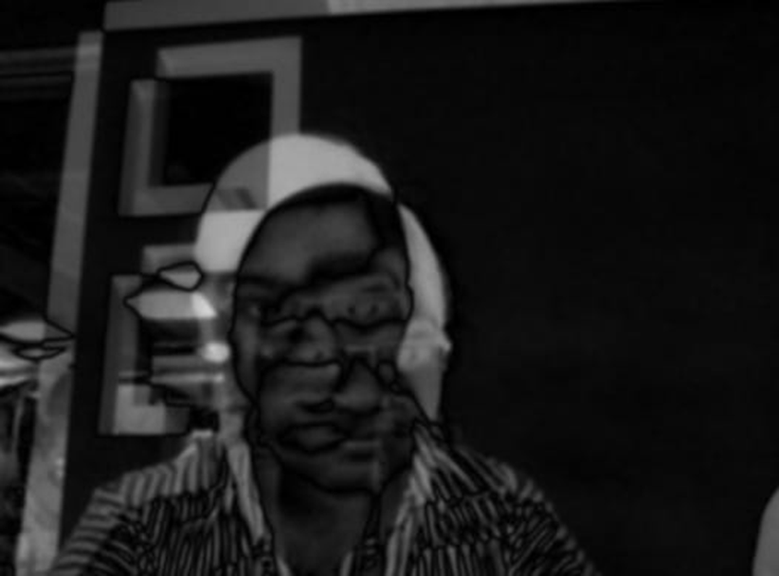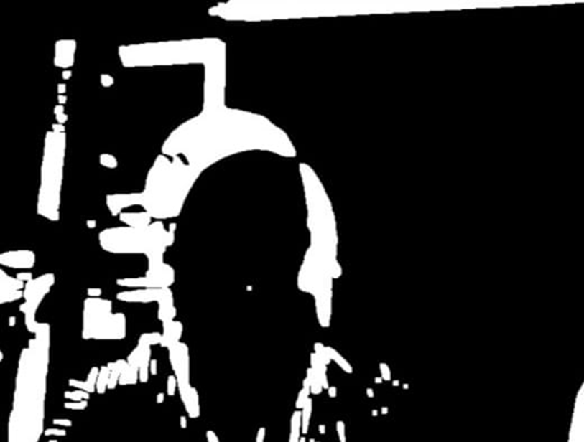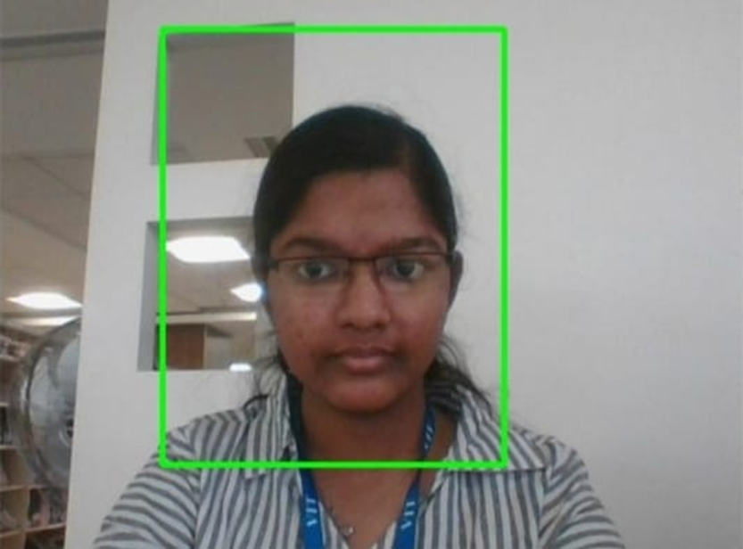
a
b
c
d
e
Fig. 2: (a) Original image, (b) Gray image, (c) Frame Difference, (d) Thresholding and (e) Detected object with motion
The original image, shown in Fig. 2.a, taken from a bright indoor environment is the input to the model. The original image is a color image that has been converted to gray image, Fig. 2.b, to reduce the complexity of the model. The difference of two consecutive frames has been calculated to detect the motion and the result is shown in Fig. 2.c. Thresholding has been applied on Fig. 2.c to quantify the change and the result has been provided in Fig. 2.d. Based on the change found after thresholding, the contour of the moving object has been detected and a green bounding box is used to visualize the object in motion. Similarly, we have applied our model with a different object and the results are shown in Fig. 3.
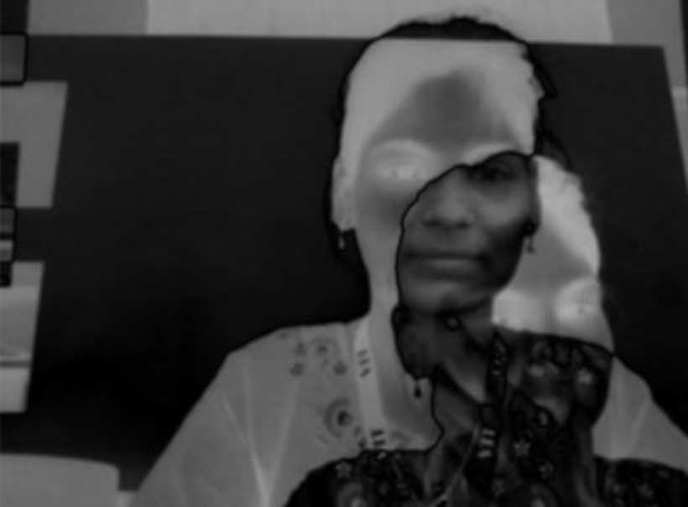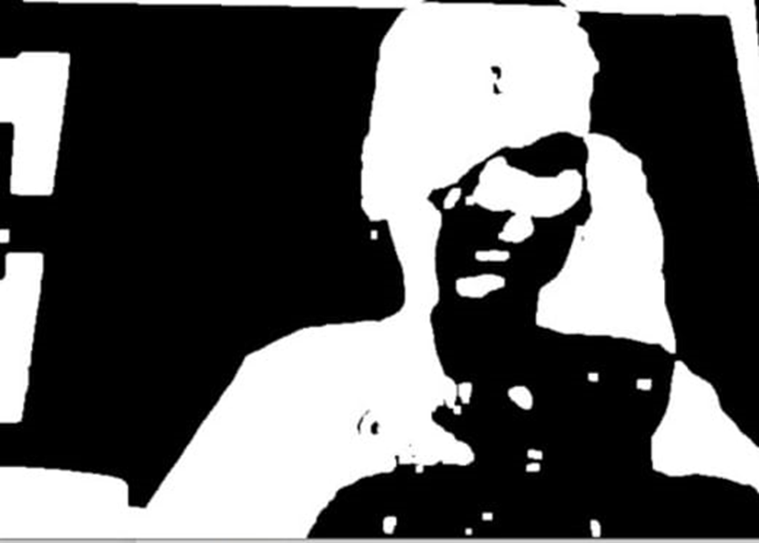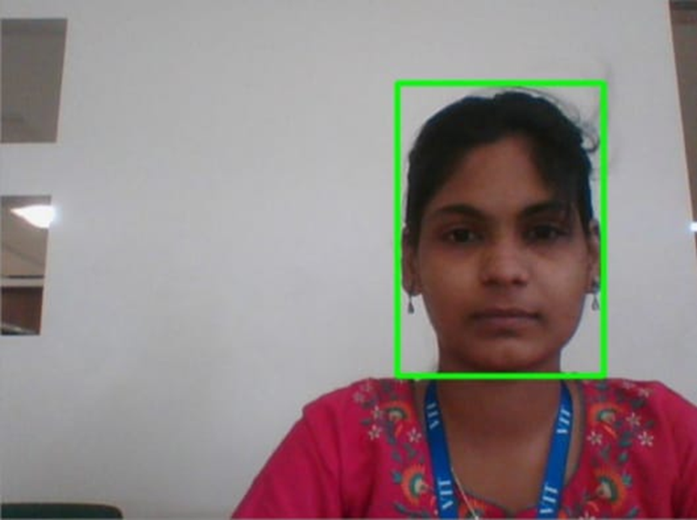
a
b
c
d
e
Fig. 3: (a) Original image, (b) Gray image, (c) Frame Difference, (d) Thresholding and (e) Detected object with motion

- Conclusion
Motion detection is one of the main building blocks of automatic surveillance. The proposed model can effectively detect an object in a bright indoor environment or outdoor environment with fixed lighting. The work can be extended for detection of objects in motion in less bright indoor and outdoor environments.

REFERENCES
- R. Kelley, M. Nicolescu, A. Tavakkoli, C. King, and G. Bebis, "Understanding human intentions via Hidden Markov Models in autonomous mobile robots," in 3rd ACM/IEEE International Conference on Human-Robot Interaction (HRI), 2008, pp. 367-374
- L. Snidaro, C. Micheloni, and C. Chiavedale, "Video security for ambient intelligence," IEEE Transactions on Systems, Man and Cybernetics, Part A: Systems and Humans, vol. 35, pp. 133-144, 2005
- D. F. Glas, T. Miyashita, H. Ishiguro, and N. Hagita, "Laser tracking of human body motion using adaptive shape modeling," in Intelligent Robots and Systems, 2007. IROS 2007. IEEE/RSJ International Conference on, 2007, pp. 602-608.
- S. Parveen and J. Shah, "A Motion Detection System in Python and Opencv," 2021 Third International Conference on Intelligent Communication Technologies and Virtual Mobile Networks (ICICV), 2021, pp. 1378-1382, doi: 10.1109/ICICV50876.2021.9388404.
- L. Spinello and K. O. Arras, "People detection in RGB-D data," in Intelligent Robots and Systems (IROS), 2011 IEEE/RSJ International Conference on, 2011, pp. 3838-3843.
- B. Choi, C. Mericli, J. Biswas, and M. Veloso, "Fast human detection for indoor mobile robots using depth images," in Robotics and Automation (ICRA), 2013 IEEE International Conference on, 2013.
- A. Bevilacqua, L. Di Stefano, and P. Azzari, "People Tracking Using a Time-of-Flight Depth Sensor," in IEEE International Conference on Video and Signal Based Surveillance, 2006, pp. 89-89.
- C. Stauffer and W. E. L. Grimson, "Adaptive background mixture models for real-time tracking," in IEEE Computer Society Conference on Computer Vision and Pattern Recognition, 1999, p. 252 Vol. 2.
- T. Tseng, A. Liu, P. Hsiao, C. Huang and L. Fu, "Real-time people detection and tracking for indoor surveillance using multiple top-view depth cameras," 2014 IEEE/RSJ International Conference on Intelligent Robots and Systems, 2014, pp. 4077-4082, doi: 10.1109/IROS.2014.6943136.
- Julien Richefeu, Antoine Manzanera, "A Newhybrid Differential Filter for Motion Detection", Ecole Nationale Superieure de Techniques Avancees, Jan 2005.
- R. Cucchiara, C. Grana, M. Piccardi, and A. Prati, "Detecting objects, shadows and ghosts in video streams by exploiting color and motion information," in 11th International Conference on Image Analysis and Processing, 2001, pp. 360-365
- A. M. Thomas, A. Ashraf, L. Lal, M. J. Mathew and M. J. Jayashree, "Security enhancement using motion detection," 2011 International Conference on Signal Processing, Communication, Computing and Networking Technologies, 2011.
- R. Radke, S. Andra, O. Al-Kofahi and B. Roysam, "Image Change Detection Algorithms: A Systematic Survey", IEEE Transactions on Image Processing, vol. 14, no. 3, pp. 294-307, March 2005
- .Davide A. Migliore," A Revaluation of Frame Difference in Fast and Robust Motion Detection", AIRLab, Politecnico di Milano, Italy, May 2006.
- S. Roy, "Motion Detection Using Image Processing," 2019 Global Conference for Advancement in Technology (GCAT).

.

